DEPARTMENT OF BIOLOGY

Minutes of the Athena SWAN Working Group held on Wednesday, 27th May 2015

Present: Calvin Dytham (CD), Adrian Harrison (ABH), Erin Haskell (EH), Jane Hill (JKH), Janina Pirozek (JCP), Jon Pitchford (JWP), Richard Waites (RW) and Mel Smee (MS)
Apologies: Boris Bongalov (BB), Amanda Barnes (AB), Helen Coombs (HC), Jen Potts (JP) and Betsy Pownall (MEP)
In Attendance: Andrea Johnson (AJJ)

15/012 Future Meetings of the ASWG and communication between ASWG members
It was agreed that in future it would be useful for the Biology ASWG meetings to be timetabled annually for a set date and time each term, avoiding half term weeks and academic staff meetings. It was agreed that the preferred time for the meetings to take place would be Wednesdays at 2.00 pm of Week 5 of each term (as long as this also avoided UCAS Admission days). It was also noted that it would be useful to have an extra meeting each year in September to avoid a long gap between meetings. AJJ will inform committee members with dates of these meetings accordingly. AJJ
JKH reported that the Chemistry Department have a Google group set up for their ASWG. Members of the Chemistry google group can easily contact other members of the group to discuss issues/pass on information, and it was debated whether this would be a good initiative for Biology to adopt. AJJ will look into the feasibility of setting up a google group for the Biology ASWG, and will arrange this accordingly. AJJ
15/013 Minutes of the Meeting of 18th February 2015
The minutes of 18th February 2015 were agreed as an accurate record, although it was noted that Adrian Harrison should be referred to as ABH rather than AH in future minutes.
The minutes of the meeting of 18th February have been added to the Biology Athena website.

15/014 Matters arising from the Meeting of 18th February 2015
- 15/003 Engagement of undergraduate students: ideas for summer term activities
It had previously been proposed that BB put on an activity for undergraduate students, and JKH reported that he had subsequently come up with a plan for a panel discussion during the careers event on the 11th / 12th June. However, as BB would himself be unable to attend that event, and as JKH is also away, it was felt that it would be better to cancel this year and work further on it for next year.

The ASWG debated whether a discussion on ‘women in science’ would be useful to include in a ‘life after University’ session. This was felt to be a good idea and JKH will speak to AB about whether some sort of Panel discussion on this issue could be included into the things she already does. JKH/AB

BB had previously had a good idea about the production of ‘shadow CVs’. JKH had suggested that he come up with a design and JKH would trial it. JKH will try to speak to BB separately about taking this forward once BB graduates. JKH/BB

EH reported that GradShare already do encourage speakers to reflect on their CVs and career progression, which was deemed useful.

It was noted that Daniel Ungar is stepping down as the Departmental Careers Officer, and will be replaced by Peter Mayhew in due course.

It was further noted that BB would shortly be finishing in his role on the ASWG, and new undergraduate representatives for the ASWG would need to be found. It was proposed that, in due course, AJJ contact the new 1st year and 2nd year undergraduate representatives to invite them to join the ASWG as undergraduate representatives. Ideally 2 representatives should be
Action

appointed (one for the 1st years, and one for the 2nd years). It should be pointed out to the new reps that their gender is not important for inclusion on the ASWG and that EH would be willing to provide further information on the role of ASWG representative if they had any queries. AJJ

- 15/004 Staff Survey 2014: discussion of data and agreed actions to follow up
It was acknowledged that there was nothing currently on the Biology Athena website about the 2014 Staff Survey. However, a summary of the survey is already available on the Biology HR website. Any related initiatives that are put in place as a result of the findings will also be advertised there, and CD will progress this accordingly. CD
It was agreed that JKH would let AJJ have a supporting ‘Athena’ statement and/or a summary sheet so that this can be added to the Biology Athena website along with a link to the data on the Biology HR website. Whist it was noted that there was not particularly anything ‘Athena-related’ arising from the findings of the Staff Survey (and therefore nothing specific for the Biology ASWG to take forward), there should be something on the Athena website to say that an analysis has taken place. JKH/AJJ

- 15/005 PhD Survey Results 2014
JKH pointed out that it would be useful to have a document summarising the PhD survey results on the Athena website.
EH advised that Keir Bailey (in her role of former PhD rep) was going to do this. JKH will therefore contact KB to ask if the raw questions (with any comments removed) along with a one-two page document summarising the results were available. This would then be passed on to AJJ for publishing on the Athena website in due course. JKH/AJJ
- 15/006 Pay Gap Data
It was queried whether the pay gap data could be placed on the web. However it was acknowledged that any data that would in any way identify individuals needs to be removed first. It was proposed that the data for ‘Readers’ and ‘Senior Lecturers’ be amalgamated and JKH agreed to feed back to Central HR that it would be good to merge the two groups. JKH would then re-run the data on tableau and check it before forwarding on to AJJ for inclusion on the Athena website. The ASWG acknowledged that any pay differential was bad. JKH
CD advised that, at the last Academic Staff Meeting, there had been no feedback from those attending on the data that had been presented so far, and it was noted that further data analysis by HR is still awaited (eg time at grade without being promoted, to supplement analysis on time in previous grade on promotion).
- 15/008 (iii) Survey of PDRAs
The national survey conducted by CROS has been run recently, and JCP reported that she should be able to get access to the findings in due course (it was noted that the survey has closed and data should be retrievable within the next couple of months). In view of the fact that the CROS survey has recently happened, it was agreed to delay surveying the PDRAs in Biology until autumn 2015.
- 15/008 (iv) Mentoring
JKH reported that she and JCP had met, and there were ongoing discussions and developments relating to mentoring, particularly at University level.
Coaching was also discussed and JCP advised that she would communicate details regarding coaching opportunities at the next Academic Staff meeting. There will also be a Biology postdoc meeting held over the summer at which coaching opportunities can be an item, and it may be possible to get Susan Kane to come along to that. JCP
JCP further advised that she had contacted Learning & Development to ask how many people had registered for coaching and in future this information should be available by gender (although it was not available at present).

Action
It was noted out that AB had some involvement with coaching in relation to postdoc careers and has led a session on this. Coaching is particularly helpful for postdocs to achieve a specific aim (eg gain an Independent Fellowship), but it was felt that until the discussions/developments at University level are concluded, it would not be effective to do anything separately in Biology.
JWP reported that there should be a Concordat implementation meeting due, and she is a member of that group, and can report back on any developments accordingly. JWP will also talk to AB about this to keep her updated of developments arising from the meeting. JWP
On the theme of support for postdocs, JKH reported that Cambridge have set up an ‘Office for Post-Doctoral Affairs’ (OPdA) to look after all postdocs at Cambridge. This was believed to be a good idea, and perhaps should be suggested to the University Athena Group. Such an initiative recognises the difficulties of interacting (eg where staff are employed on short term contracts, etc) and may help postdocs feel more included.

15/015 Updated Staff/Student Data
Updated charts had been circulated with the Agenda.
- Figure 1 related to undergraduate Biology & Biochemistry students

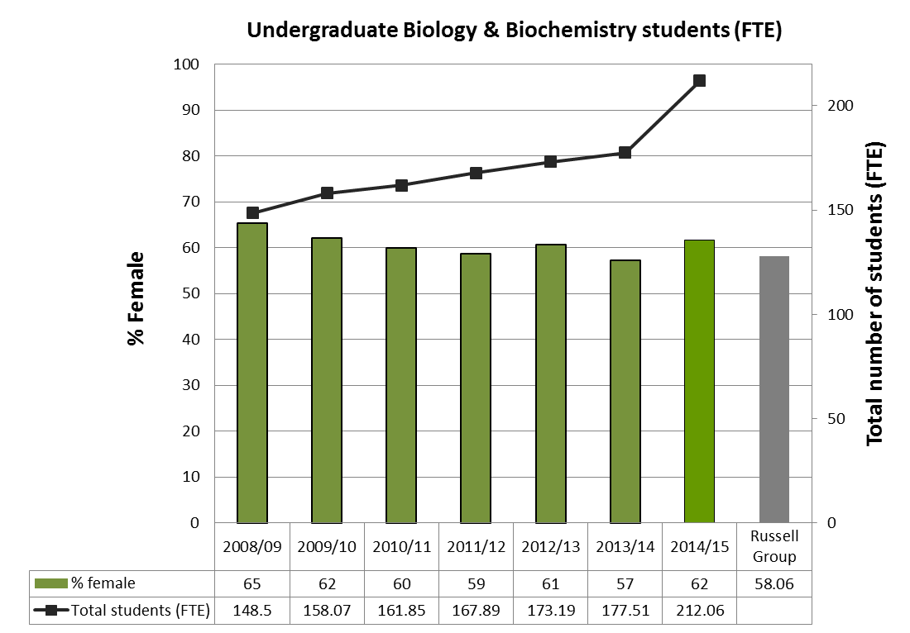
Figure 1. Green bars show % of female u/g Biology and Biochemistry students over the past 7 years, compared to UK average (grey bar). Black line & squares show total numbers of 1st yr u/g students.
Data had been provided for the years 2013/14 and 2014/15, along with comparator data from the Russell Group. It was noted that data for BMS were not shown as these data are not currently available for download from Tableau.
Ultimately it was felt that it may be useful to separate out different degree programmes as time progresses and show separate data/charts (i.e split into ‘Biology’, ‘Biochemistry’ and ‘Biomedical Sciences’).
It was agreed that it would be beneficial to wait a year or two and then analyse the data to see what effect the new BMS programme is having on student gender ratios.

- Figures 9 and 10 related to Academic Staff by Grade and Research Staff by Grade
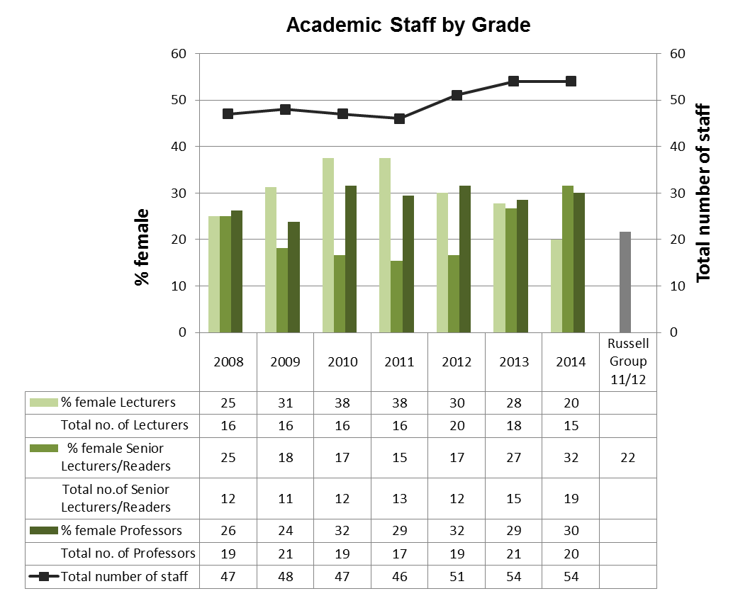

Figure 9. Green bars show the % of females at each academic grade compared to the UK average (grey bar; average of all grades). Black line and squares show the total numbers of staff.

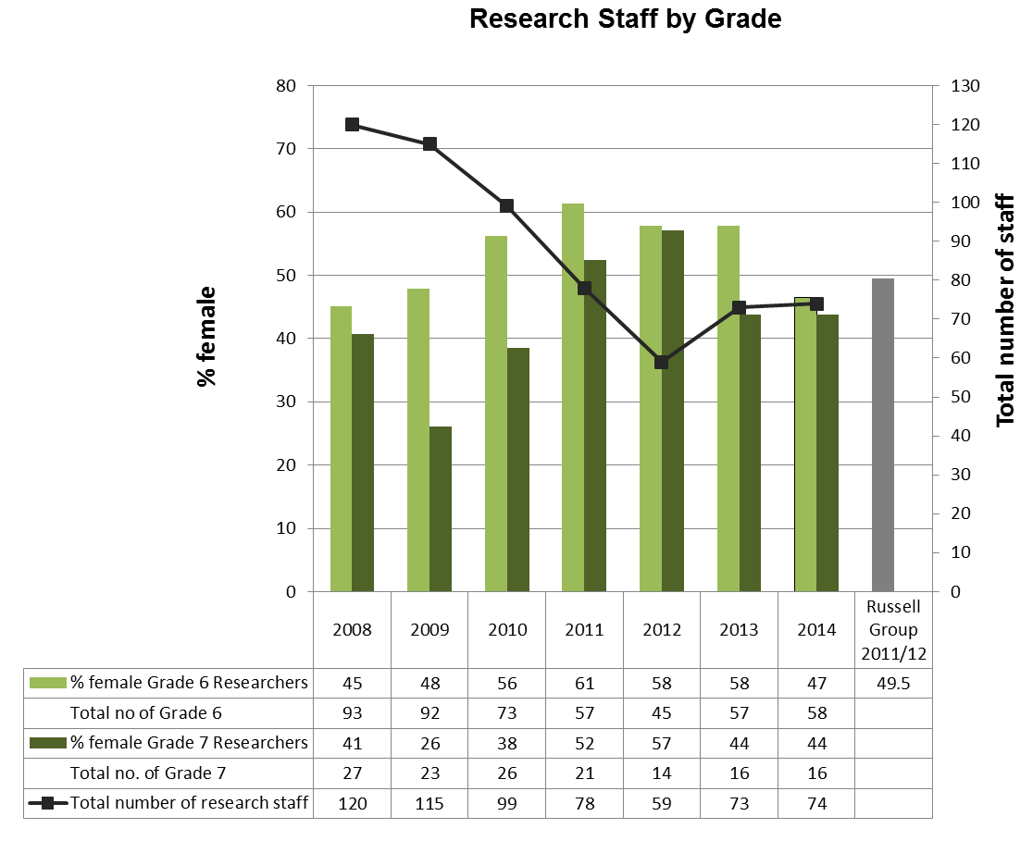

Figure 10. Bars show % of female researchers at grades 6 (light green) and 7 (dark green). Black line and squares show the total numbers of research staff.

Action
It was noted that benchmarking comparator data (the Russell Group) had not been available. HR had been contacted for this but had not yet supplied the relevant information. The comparator data shown in the figures therefore related to the 2011/12 year which had been obtained at the time of our Gold submission.
It was evident that there had been a reduction in female academic lecturers, although the number of female Senior Lecturers/Readers was higher, implying good practice in promotions. But these promotion females do not seem to have been replaced by new female Lecturers happened. It was acknowledged that a lot of male lecturers had been recruited recently, and it was queried if these data should be presented at the next Academic Staff meeting. JCP agreed that she would try and get recruitment data from Central HR (unfortunately these are not currently available from Tableau), prior to the next ASWG meeting. This would reveal if there were an equal number of male/female applicants for posts and the comparative number of males/females shortlisted for interview. JCP would also take the issue, along with the associated recruitment data, to the next Academic Staff meeting. JCP
JCP reported that when a shortlist had been drawn up of a single gender, it could be advantageous to have a discussion about whether to include a member of the opposite gender into the shortlist. Such a discussion had taken place recently, comparing the top ranked candidate from the non-represented gender that had not been selected, with the lowest rank on the short list. As a result of the discussion. changes to the short list had been made and this was felt to be successful.
In relation to the research data that were presented, JCP advised that there was a lot of recruitment currently ongoing, and it would be useful to re-visit these data at the spring meeting next year to see what impact this has on the data.

More generally it was felt that it would be useful to have a list of types of data that ware gathered for the Gold submission, and AJJ will draft this accordingly, to aid with the annual updating. AJJ

It was proposed that AJJ should also continue to get updated data from Tableau and revise the histograms (approximately 15) that had been used for the Gold submission with the updated data. These would then be analysed at the next meeting to see where changes have taken place. AJJ will progress this over the summer. AJJ

It was noted that once the graphs have been updated with the most up-do-date figures available, they would be added to a copy of the Gold submission application form in a shared folder. This would essentially be an ongoing ‘working’ document, and JKH would be able view and update the associated text for each updated analysis, based on the updated data once they have been analysed.

15/016 Developing a Resource Library
It was recognised that books can be useful as a source of reference, and it was agreed that it would be useful to develop an ‘equality’ library of interesting books and articles that members of Biology staff could dip into if interested.
One way of broadcasting this to staff would be to add a link to the Biology Athena webpage with a title, for example of ‘Books/Articles’. From there interesting articles could be included as web links (articles could be found and added by searching other equality websites). There could also be a list of books that the Department had available for loan and a covering sentence could be included on the webpage, for example along the lines of “The following books are available for loan. If you wish to borrow one, please contact …” It was agreed to set this up accordingly. JKH/JCP will let AJJ have any relevant books/links and AJJ will amend the website as appropriate.
JKH/JCP/AJJ
15/017 Changes to Athena Swan nationally
JCP tabled a document regarding changes to the Athena Swan Charter (Appendix 1, attached). In future arts, humanities, social science, business and law departments (AHSSBL) can apply for an award alongside the science, technology, engineering, mathematics and medicine (STEMM) disciplines. The expanded charter will allow for more explicit consideration of professional and support staff, and at an institutional level submission, trans staff and students.

Action

The document had been put together by Linda Whiting (Equality and Diversity Office), and it was noted that the changes to the Charter would have a big impact, both at University level and for Departments.

15/018 Changes to the Terms of Reference and title of the Biology Athena Swan Working Group
Leading on from changes to Athena Swan nationally, it was debated what the change to Athena will mean to the Biology group. It was noted that it was difficult to talk about specific issues without baseline data but it was accepted that the Biology group would in effect become more of an ‘equality and diversity’ group. It was agreed that any new remit of the group will be discussed at a subsequent meeting.
In relation to the change of title, it was proposed that the Biology Group is therefore renamed the ‘Equality and Diversity Working Group’ (again to be discussed and/or approved at the next meeting).
The terms of reference would need updating to reflect the new title and remit, and the group would need widening to incorporate additional members, eg the Department’s Disability Officer. It was felt that their inclusion in the Biology group would give support to the Disability Officer, and would therefore be beneficial to him/her. Other possible group members would include e.g. support staff representatives (eg for technical and admin roles), and this too will be discussed at the next meeting.
15/019 Action Plan – agreed timetable of activities for the next 3 months
The Working Group will look further at the Action Plan at the next meeting in view of the fact that updated data and charts will be provided then (minute 15/015 above).
15/020 Report on Beacon Activities / News for the website
It was noted that some details regarding the recent ‘Pint of Science’ festival had now been placed on the website.
JKH reported that she had visited both the University of Exeter and Bournemouth University to talk about Athena Swan related matters. JKH had also visited the Wellcome Trust for a YouTube video to be made. JKH will let AJJ have a link to the YouTube video for the Biology website in due course. JKH
JCP advised that she had been invited to visit the Associate of Research Managers and Administrators to talk about Athena (at which a video was made of her presentation). JCP will let AJJ have a sentence for adding to the news section of the Biology website. JCP
The Group were reminded to let AJJ have any AS news items for the website, along with a suitable photograph where possible.
15/021 Items to be communicated to the Academic Staff Meeting
JKH advised she was unable to attend the next academic staff meeting which is scheduled for the 24th June 2015 as she was away.
However, she and JCP would prepare two slides to take to the following academic staff meeting, in autumn 2015. These would be firstly a slide about coaching at the University (as per minute 15/014 (vi) above) and, secondly a slide about academic staff and gender ratios with associated recruitment data (as per minute 15/015 (ii) above).
15/022 Date of Next Meeting
September 2015 (proposed date/time - 9th September at 2.00 pm).

AJJ - 08/06/2015

